**JAVAIRIA REHMAN**

**19P-0020**

**BS(CS) 19-5A**

**“computer networks ”**

**wireshark home work**

**Ping plotter**

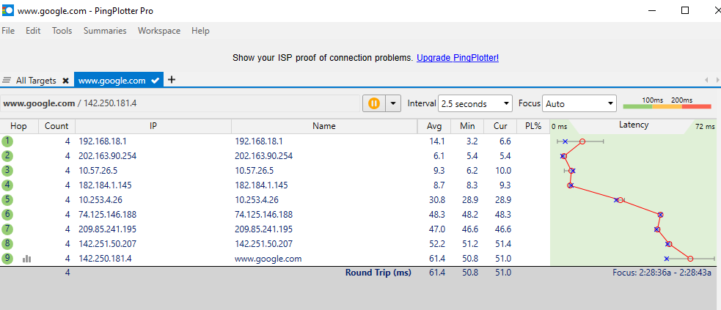

**Question 1**

**wireshark**

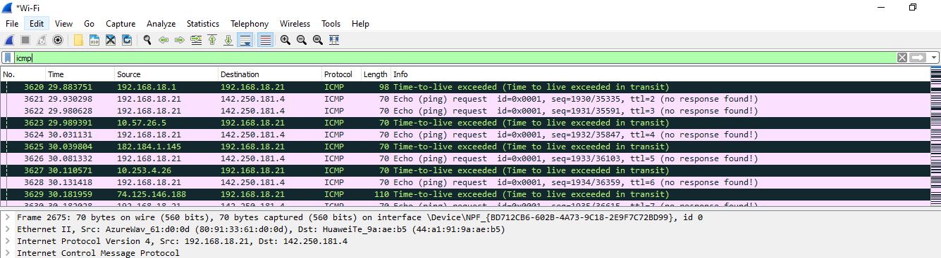

Source=192.168.18.21

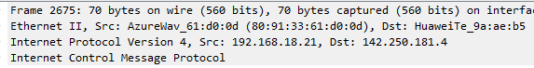

**Question 2**



icmp1

**Question 3**

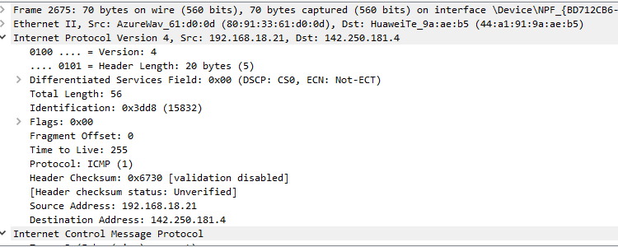

20 bytes.

Header length= 20

Total Length= 56

Payload Bytes= 56 – 20= 36

**Question 4**

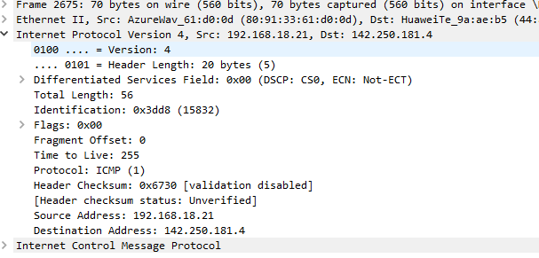

No, because we don’t see any ipv4 fragments

**Question 5**

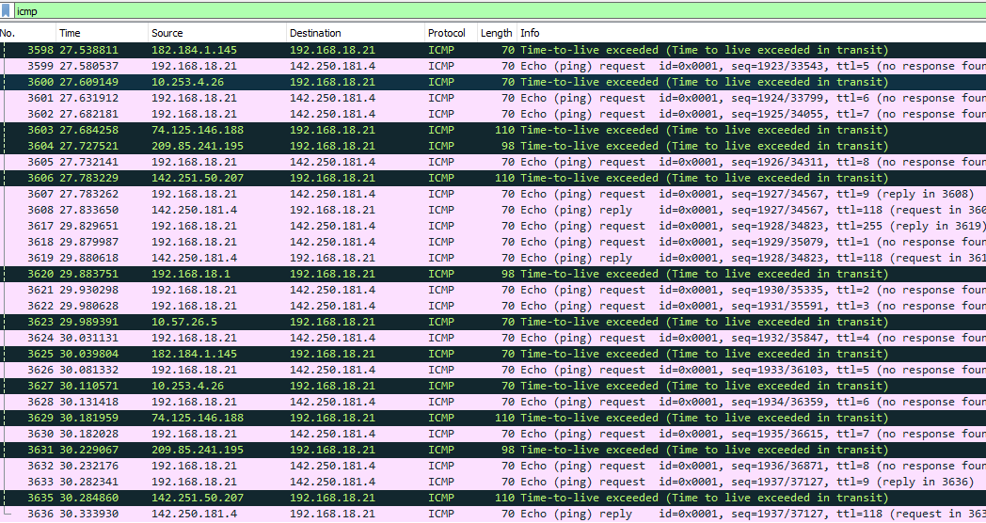

Seq and TTL are changing with each packet.

**Question 6**

* Version, header length, source IP, destination IP, upper layer protocol remain constant.
  + The version and header length will remain same because we are using ipv4.
  + The source and destination ip address remain the same as they are not changing.
  + Upper layer protocol is not changing because we are using the same protocol every time. Sequence Number and Time To Live are changing.
  + Each packet will have a different sequence number.

**Question 7**

Increase by 1

**Question 8**

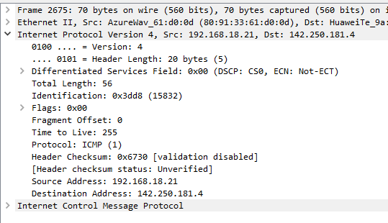

* Identification Field: 0x3dd8 (15832)
* Time To Live: 255

**Question 9**

The identification field changes with the each datagram but the TTL remains the same

**Question 10**

Yes

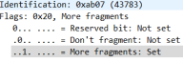

**Question 11**

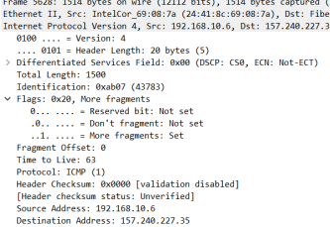

* the flag for more fragments has been set which means the datagram has been fragmented.
* the fragment offset is 0, which tells us that this is the first fragment.
* The total length is 1500 including the data and the header

**Question 12**

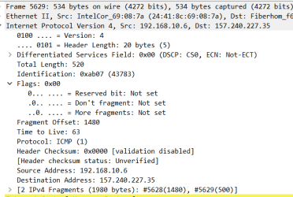

* this is the last fragment because the more fragments flag is not set
* the fragment offset is 1480.

**Question 13**

* total length
* flags
* fragment offset

**Question 14**

Only one additional packet is created

**Question 15**

* total length
* flags
* fragment offset